Alan Truong

**Individual Report**

The part of the project that I worked on was the keyboard function in the group project and the LED. I also help out with making the part of the play note function and the some part of the UART. But for the keyboard function, I made it so the user are able to press one of the three switch on the first row and it will either play an E, C, or D notes. The user are able to hold onto the switch and the note will continuous play by continuously sending out a square wave. So the hold note function was created in order for the user to hold onto the button. All the calculation was done together as a team for what frequency was used for each note and that was documented into our group report. I used Timer 1 for the note that was less than 16 bit.

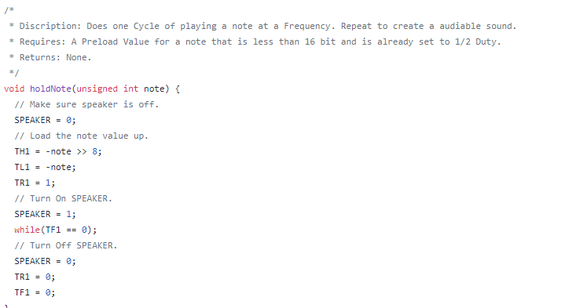

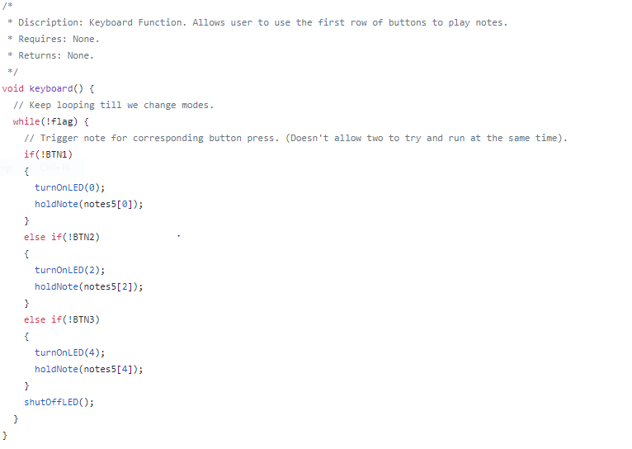

For my individual project I made it so whenever a certain type of note is being play then a certain LED will be turn on. So I made a turn on led and a shut off led function called turnOnLED and shutOffLED. The turnOnLED has it where takes in a Char that will tell the turn on function what notes is being play in order for it to turn on the led. turnOnLED function will always call shutOffLED to turn off all LED before it turns on a new one, since only one note is being play at a time. Then in the switch case of turnOnLED function it will take the number that is passed in and for case 0 and 1 are for C notes, but there we use C and C Sharp note, but because we don’t have enough LED on the board I combine sharp and flat notes for 1 LED. Case 2 and 3 was used for D notes, Case 4 was for the E note, Case 5 and 6 for F notes, Case 7 and 8 was for the G notes, 9 and 10 was for A notes and lastly Case 11 of the function was for B note. For the shut off led function I just set every single LED port to 0 making sure they will be all off. I put the Turn on Led and Shut off led into the keyboard function which, the display notes function and the keyboard 2 function therefor whenever a sound is coming out of the speaker the LED will light up accordingly to the note being played. Then I put the shutoff led after every function called and the switch case after the song is finish playing so after the note is play the led will be shut off. Below I attach the function where the turnOnLED and shutoffLED function is called and then definition of the two function.

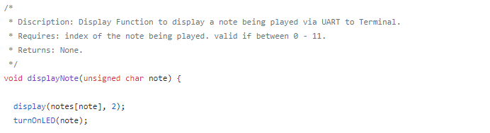

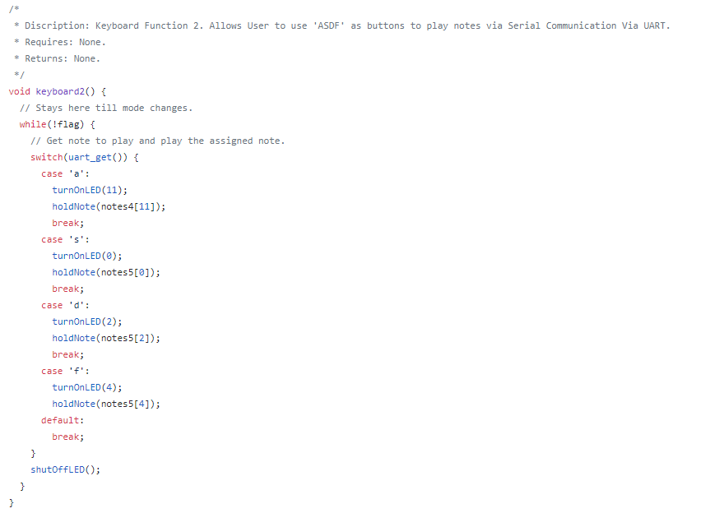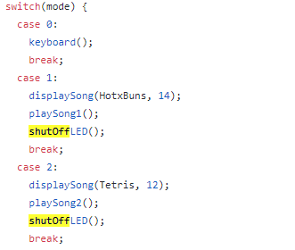

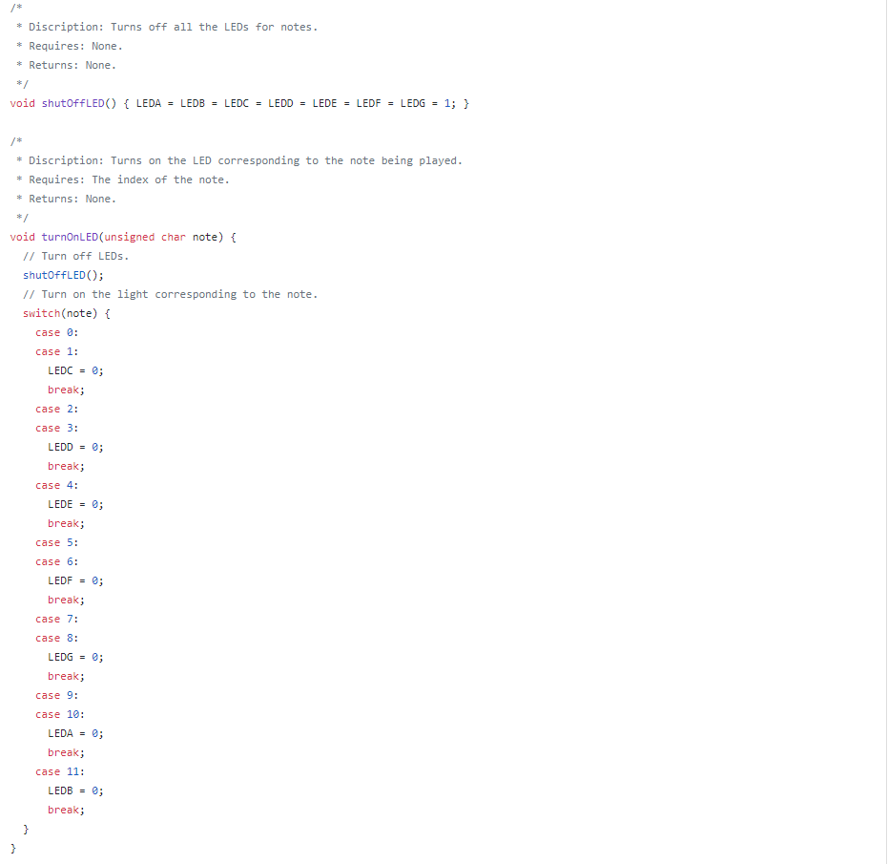

I used Port 2.4, 0.6, 2.7, 0.6, 1.6, 0.4, and 2.5 on the Simon board for the led. And for the keyboard switches I use Port 2.0, 0.1, and 2.3 for the keyboard function. Lastly, I use port 1.7 for the speaker to output sounds.

s